**SHORT PASS MINI GAME DESIGN DOCUMENT**

**Game Explanation**

The player follows a path to the goal by passing ball to his/her friends among the moving opponents. He/She tries to score a goal from his current position when he has a chance to score a goal.

**Gameplay**

The game has a 2D overhead view. The field includes opponents, friends and ball. The player tries to pass the ball to his/her friends by hitting the ball with proper angle and force. After the successful pass, the game screen will switch to the scene where the other pass will be thrown or to the shooting scene if the end of the level is reached. Unsuccessful passes and no goals will result in the loss of the game.

**Gameplay Mechanics**

The game makes opponents and friends come to go along a certain route. The player shoots the ball in the direction of the vector which is created by pulling the ball. If the ball reaches the friend, the next scene will show up.

**Level Design**

As you make progress in the levels, the number of passes that player has to score and the number of opponents around the friends increases. As you make progress through the levels, opponents make sudden moves to making it difficult to predict. The goalkeeper’s speed at the front of goal increases. Total number of levels is five. The number of pass scenes the levels have increases each level by 1. At the end of the every level there is a shoot scene.

**Game Interface**

The game is designed to be played on phones so it has a touch interface. The player moves the ball by hitting the ball with a vector created by pulling the ball. The generated vectors appear on the screen as a yellow colored arrow. The objects on the field have a circular design. Friends are blue, opponents are red and the ball is black-white. The ground is completely green except the shooting scene. For the shooting scene there are field lines on ground.

**EXAMPLE PASS SCENE**

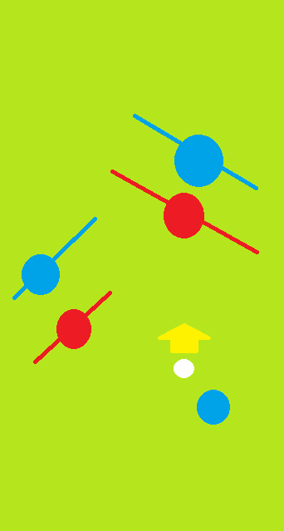

**EXAMPLE SHOOT SCENE**

